GH-900 Lab Manual: GitHub Foundations

Section 1: Setting Up Your GitHub Account
Objective: Guide learners through creating and securing a GitHub account.
Steps:
1. Visit GitHub.com and click Sign Up.
2. Choose a username, email, and password.
3. Verify your email address.
4. Enable Two-Factor Authentication (2FA):
- Use SMS or an authenticator app.

Section 2: GitHub Basics
Objective: Introduce Git and GitHub fundamentals.
Topics Covered:
- Version Control Systems (VCS)
- Git vs GitHub
- GitHub Flow
- Repository creation and management
- Branching and merging
- Issues and pull requests
Hands-On Exercises:
- Create a repository
- Clone a repository
- Create and merge branches
- Submit and review pull requests
How to create a repository
You can create a new repository on your personal account or any organization where you have sufficient permissions.
Let’s walk through how to create a repository from github.com.
- In the upper-right corner of any page, use the drop-down menu, and select New repository.
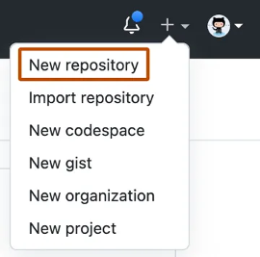
- Use the Owner drop-down menu to select the account you want to own the repository.
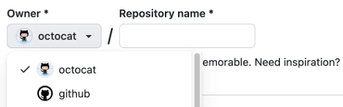
- Type a name for your repository, and an optional description.
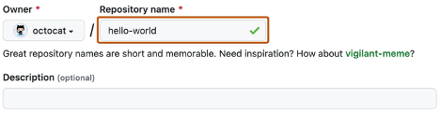
- Choose a repository visibility.
  - Public repositories are accessible to everyone on the internet.
  - Private repositories are only accessible to you, people you explicitly share access with, and, for organization repositories, certain organization members.
- Select Create repository and congratulations! You just created a repository!
How to clone a repository
Cloning a repository allows you to create a local copy of a repository on your computer. This is useful for making changes locally and syncing them back to the remote repository.
- On GitHub.com, navigate to the main page of the repository you want to clone.
- Above the list of files, click the Code button.
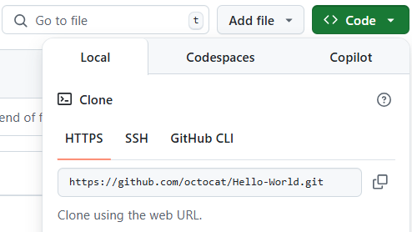
- Copy the URL for the repository using the HTTPS, SSH, or GitHub CLI option.
- Open your terminal and navigate to the directory where you want to clone the repository.
- Run the following command, replacing <repository-url> with the URL you copied:
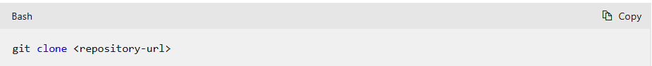
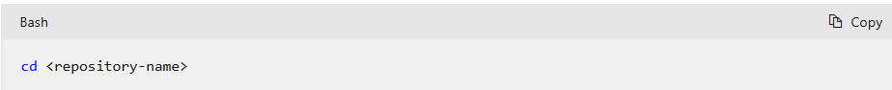
Congratulations! You now have a local copy of the repository.
Next up, let’s review how to add files to your repository.
How to add a file to your repository
Files in GitHub can do a handful of things, but the main purpose of files is to store data and information about your project. To add a file to a repository, you need at least Write access.
Let’s review how to add a file to your repository.
- On GitHub.com, navigate to the main page of the repository.
- In your repository, browse to the folder where you want to create a file by selecting the creating a new file link or uploading an existing file.
- Once added, above the list of files select the Add file ᐁ drop-down menu. Then select Create new file.
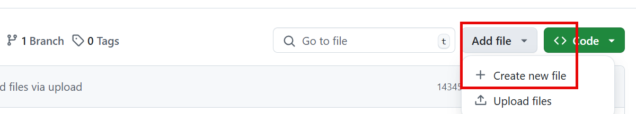
- In the file name field, type the name and extension for the file. To create subdirectories, type the / directory separator.
- In the file contents text box, type content for the file.
- To review the new content, above the file contents, select Preview.
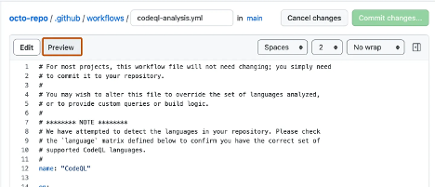
- Select Commit changes.
- In the Commit message field, type a short and meaningful commit message that describes the change you made to the file. You can attribute the commit to more than one author in the commit message.
- If you have more than one email address associated with your account on GitHub.com, select the email address drop-down menu. Then select the email address to use as the Git author email address. Only verified email addresses appear in this drop-down menu. If you enabled email address privacy, then [username]@users.noreply.github.com is the default commit author email address.
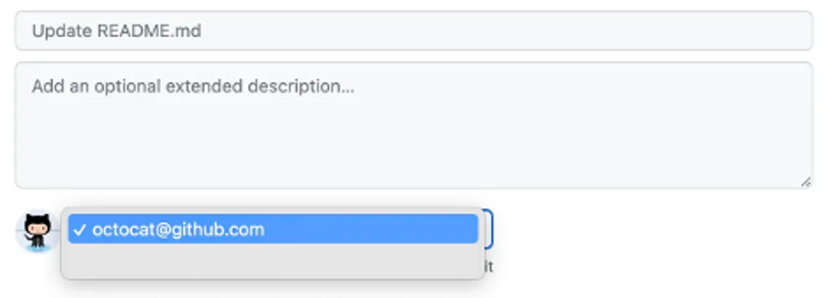
- Below the Commit message fields, decide whether to add your commit to the current branch or to a new branch. If your current branch is the default branch, you should choose to create a new branch for your commit, and then create a pull request.
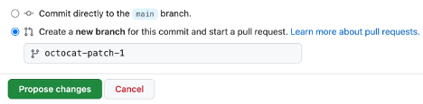
- Select Commit changes or Propose changes.
Congratulations, you just created a new file in your repository! You have also created a new branch and made a commit.
Before we review branches and commits in the next unit, let’s quickly review gists, wikis, and GitHub pages because they're similar to repositories.

Section 3: Essential Git Commands
Objective: Practice core Git operations.
Commands:
- git status
- git add
- git commit
- git log
- git checkout
- git merge
Lab Activities:
- Track changes in a local repo
- Resolve merge conflicts
- Use git log --merge and git diff for conflict resolution
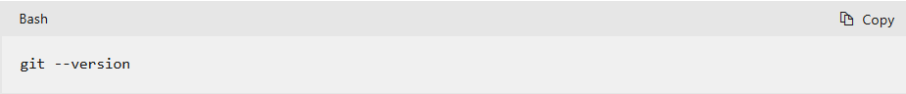
Set your name in Cloud Shell with the following command. Replace <USER_NAME> with the user name you want to use.
Now, use this command to create a user.email configuration variable, replacing <USER_EMAIL> with your e-mail address:
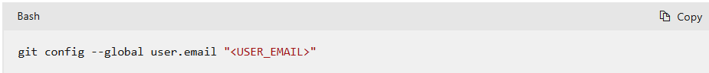
Run the following command to check that your changes worked:
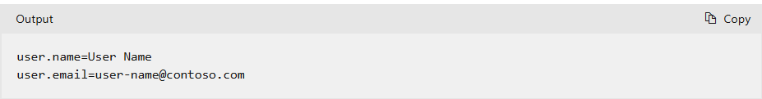
Create a folder named Cats. This folder will be the project directory, also called the working tree. The project directory is where all files related to your project are stored. In this exercise, it's where your website and the files that create the website and its contents are stored.
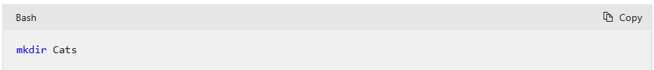
Change to the project directory by using the cd command:
cd Cats
Now, initialize your new repository and set the name of the default branch to main:
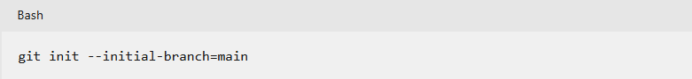
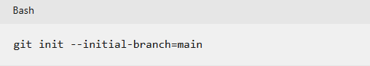
Now, use a git status command to show the status of the working tree:
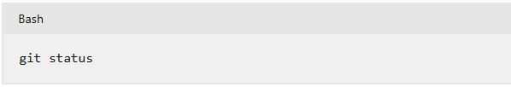
Type the following command to get help with what you can do with Git:
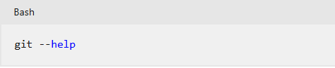
Manage Merge Conflicts
Create and Resolve Git Merge Conflicts—perfect for hands-on in GH900 sessions:

🔧 Simulating a Merge Conflict – Step-by-Step
🟢 Step 1: Set up the test repo
mkdir git-merge-test
cd git-merge-test
git init .
echo "this is some content to mess with" > merge.txt
git add merge.txt
git commit -am "we are committing the initial content"
✅ Creates a new repo with one file merge.txt committed to main.

🟡 Step 2: Create a conflicting branch
git checkout -b new_branch_to_merge_later
echo "totally different content to merge later" > merge.txt
git commit -am "edited the content of merge.txt to cause a conflict"
✅ New branch new_branch_to_merge_later now has conflicting content in merge.txt.

🔵 Step 3: Add changes to main branch
git checkout main
echo "content to append" >> merge.txt
git commit -am "appended content to merge.txt
✅ main now has its own new commit. Both branches have diverged.

🔴 Step 4: Merge and trigger the conflict

git merge new_branch_to_merge_later
💥 Git throws a merge conflict in merge.txt. Time to resolve!

🔍 Diagnosing the Conflict
🧭 Check conflict status
git status
🔎 Shows merge.txt as unmerged and modified in both branches.
📖 View conflict markers
cat merge.txt
You’ll see:
<<<<<<< HEAD
this is some content to mess with
content to append
=======
totally different content to merge later
>>>>>>> new_branch_to_merge_later

🧩 These are conflict dividers:
- <<<<<<< HEAD = current branch (main)
- ======= = separator
- >>>>>>> new_branch_to_merge_later = incoming changes

🛠️ Resolving the Conflict
✏️ Edit the file manually
Open merge.txt and clean it up. Example:
this is some content to mess with
content to append
totally different content to merge later

✅ Stage and commit the resolution
git add merge.txt
git commit -m "merged and resolved the conflict in merge.txt"

Section 4: GitHub Projects and Collaboration
Objective: Explore GitHub’s project management features.
Topics:
- GitHub Projects (Kanban boards)
- Milestones and labels
- Notifications and subscriptions
Lab Activities:
- Create a GitHub Project
- Assign issues and track progress
- Collaborate using comments and reviews
Creating an organization-owned Project
First, you want to lay the foundation by creating a new Project. Creating is relatively quick and simple.
- In the top right corner of GitHub.com, select your profile photo, then select Your organizations.
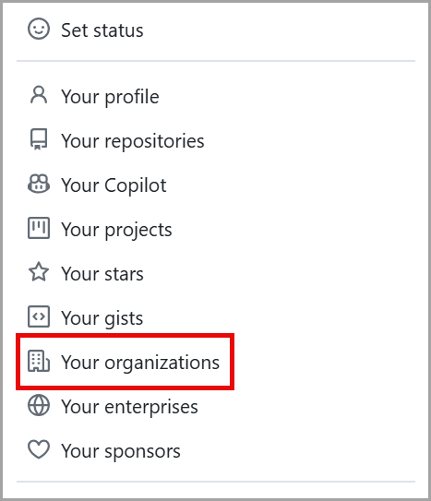
Screenshot of the Profile Dropdown Menu that includes Your profile, Your repositories, Your Codespaces, Your organizations, and Your enterprises with Your Organization option highlighted.
- Scroll down to select the organization for your new Project.
- Navigate from the Overview tab to the Projects tab.
- Select the green button labeled New Project.
- A pop-up prompts you to select either a template or start from scratch. Let's choose the Start from scratch option and select Table.
- Select the green Create project button.
You just created a Project!
Tip
You can also create a personal Project by selecting your profile photo and navigating to Your projects, then clicking New project.
Additionally, Projects can be created directly from a repository—this links the repository to the Project automatically, though the Project itself is still created at the organization level and can be linked to other repositories or projects in the future.
Set your Project's name, description, and README
Let's define your Project in a couple of different ways so that your team can easily understand what you're tracking.
- Navigate to your newly created Project to edit your Project's name, description, and README.
- At the top right of the page, select the three dots to open the menu and select Settings.
- Project Name is where you edit the name of the Project.
- Short description allows you to add a few words about the Project.
- README lets you add information for your team to understand why you created this Project and what you hope to accomplish with it. Once finished, select Save changes.
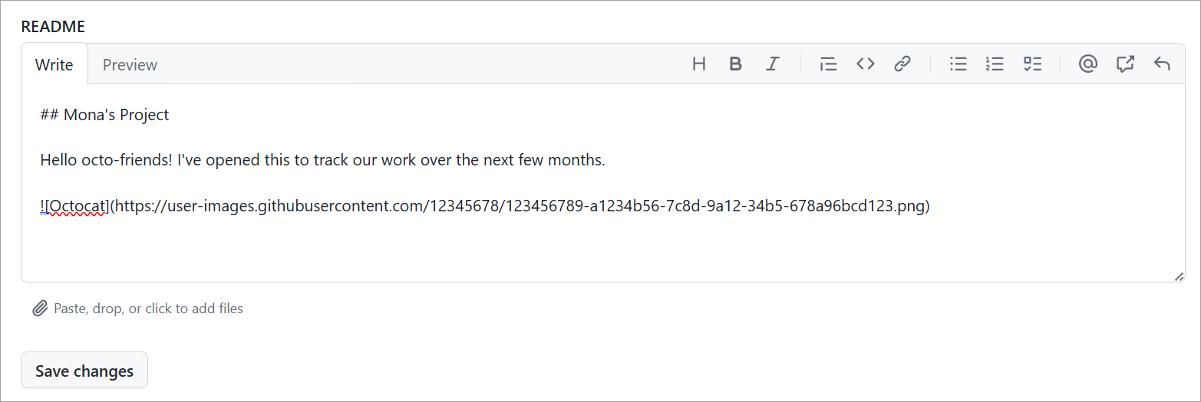
Add issues and pull requests to your Project
Adding issues and pull requests to your Project is what makes the tool so powerful. Projects enable you to know the status of tasks your team is working on to coordinate and complete your goals.
Let's go through the different ways to add issues and pull requests to your Project.
Add an existing issue and pull request
- Copy the url of an existing issue or pull request.
- Place your cursor in the bottom row of the Project next to the + and paste the URL of your issue or pull request.
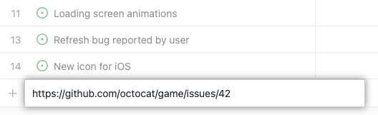
- Press Enter and your issue or pull request appears as a task in your Project.
Search for an existing issue and pull request
You can search for existing issues or pull requests by adding a new item.
- Enter # to search repositories. You can type part of the repository name to narrow down your options.
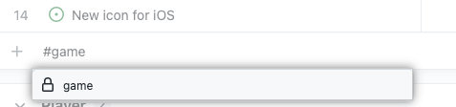
- Select the repository where the pull request or issue is located, which prompts to search issues and pull requests.
- Start typing the title of the issue or pull request to find the one you want.
- Select the issue or pull request.
Bulk add issues and pull requests
You can bulk add issues and pull requests to an existing repository to save time. It allows you to start organizing your team faster.
- Select + in the bottom row of the Project.
- Select Add item from repository.
- To change the repository, select the dropdown and choose a repository. The issues and pull requests then populate.
- You can either select all or select those issues or pull requests you want to include.
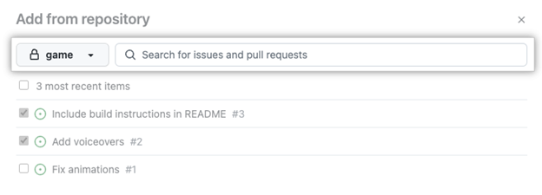
- Once you're ready to add the issues and pull requests to your Project, select the green button titled Add selected items in the bottom right corner.
Project workflows
To help streamline work, GitHub Projects supports default workflows. These allow items like issues and pull requests to be automatically added to a Project and marked with an initial status, like "Todo".
To enable a workflow:
- Open your Project.
- Select the three-dot menu in the top-right and choose Workflows.
- Choose a trigger like “Item added to project”.
- Set values, such as Status: Todo.
- Select Save and turn on workflow.
Convert checklist items into sub-issues
As of February 2025, GitHub Projects supports converting checklist items into sub-issues. This feature makes it easier to break down tasks into smaller, trackable work items—directly from an issue.
To convert a checklist item:
- Create or open an issue that contains a checklist.
- Hover over the checklist item.
- Click the ... menu next to the item.
- Select Convert to sub-issue.
This creates a linked issue that appears in your Projects view with its own status, metadata, and tracking. Sub-issues provide better visibility into related work and replace the older tasklist block feature, which was deprecated on April 30, 2025.
In the next unit, you'll learn how to organize and prioritize your Project in order to keep your tasks on track.
Create a field to track and group by priority
To group a set of issues and pull requests by priority, you need to first create a new field.
- In the table view, in the rightmost field header, select +.
- Select New field.
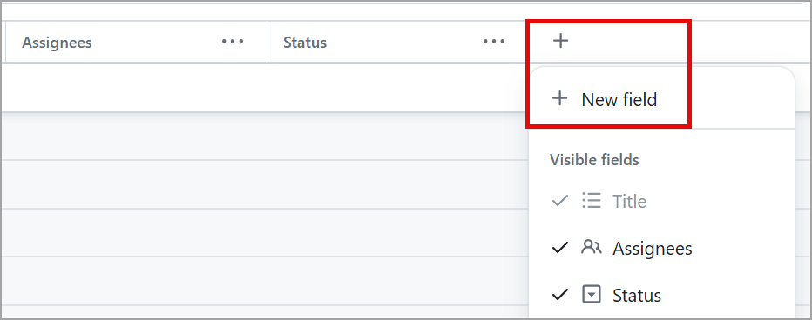
- Type the name of your field. In this case, it's Priority.
- Select the Field Type drop-down.
- To create your own classification for your new field, select the Single select option.
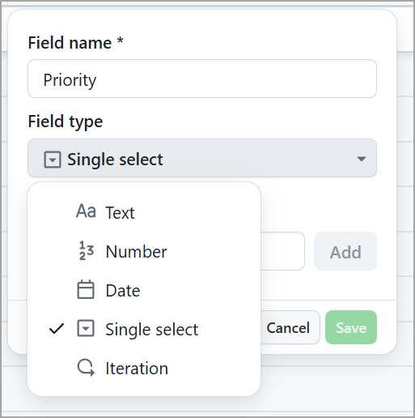
Screenshot of the drop-down menu for a New Field that contains Text, Number, Date, Single select, and Iteration with the Single Select option highlighted.
- In the Options text box, start to add your different priority levels. You can label them as Urgent, High, Medium, and Low.
- Select Save.
Now that you have your priority classification set up, you need to classify your issues and pull requests based on priority. To make a classification, select the issue or pull request you want to classify in the field row titled Priority. Now, in the drop-down field, select the priority you want to choose for this particular issue or pull request.
Repeat for your remaining pull requests and issues.
Great!
Now, let's group your issues and pull requests by priority to make it easier to focus on urgent and high priority items.
- Select the down arrow next to the name of your currently opened view.
- Select the Group by option.
- Select Priority.
Now you should be able to view issues and pull requests based on the priority you assigned them. One of the great features of this particular view is you can now drag and drop issues into new priority fields easily.
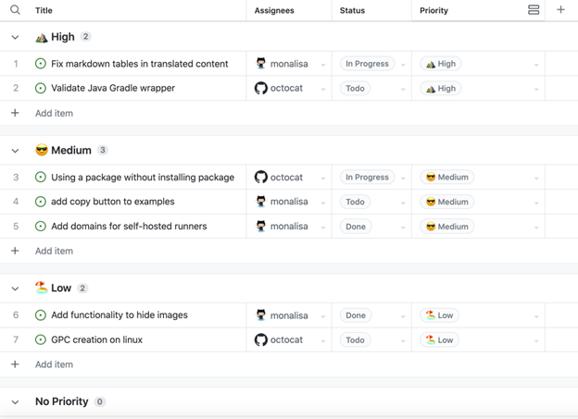
Screenshot example of Priority Classification within Project List view with Issues and Pull Requests that are organized and grouped as High, Medium, and Low classifications.
Now that you have your work prioritized, let's tackle timelines and iterations.
If you want to save this view, select the Save changes button on the top-right of the list view.
Add an iteration field
Adding an iteration field to your Project can help you and your team visualize the balance of upcoming work in order to help everyone stay on track. An iteration field enables you to set up phases for your tasks in a tangible timeframe to keep you and your team organized.
- To add an iteration field, go to your Project's table view.
- In the rightmost field header, select +.
- Select New field.
- Add a Field name, such as Project Phase or Sprint.
- Under Field Type, select Iteration.
- Choose a Starts On date.
- Change the Duration of each iteration by typing a new number, and select the drop-down for either days or weeks as follows.
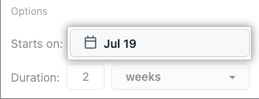
- Select Save and create.
Once you have your iteration field set up, you can now assign what iteration phase you want each of your issues and pull requests to fall under.
Now that you've prioritized and organized your Project, let's take a look at how to view your Project from a board view perspective.
Create a board view
A board view of your Project enables you to view upcoming tasks in a more visual way.
Let's walk through how to get your board view up and running.
- On the currently open view, select the down arrow.
- Under Layout, select Board. When you change the layout, your Project displays an indicator to show the view was modified.
- Select the Save button at the top-right of the board.
- You can rename the view by double-clicking the view's tab, and selecting out of the tab to automatically save.
- Note these steps can also be accomplished by selecting New View to the right of your existing views.
Now, you can drag and drop issues and pull requests to the various columns.
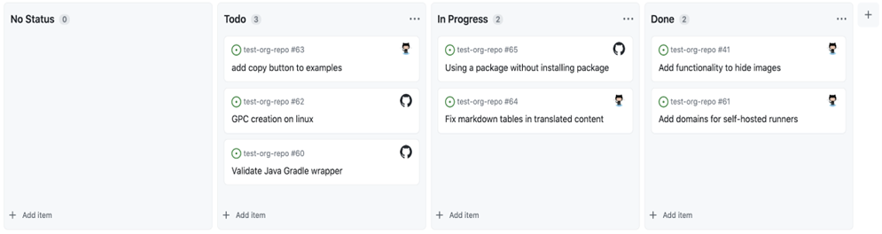
Project workflows
To automate common actions, GitHub Projects includes built-in workflows that help organize and update project items automatically.
For example, when a new issue is added to your Project, a default workflow can set its status to "Todo". Here's how to enable a workflow:
- Open your Project.
- Select the ⋯ menu in the top-right and choose Workflows.
- Select a trigger (e.g., "Item added to project").
- Configure values like Status: Todo.
- Click Save and turn on workflow.

